**Read Me:**

Summary:

Developed a program that trains a CNN model to detect whether a potato plant is healthy, has early, or late blight. Blight is a disease common in potatoes and tomatoes that causes the plant to become poisonous for consumption and stunts the development of the plant. Late blight is the cause of the Irish Famin from 1845 to 1849, causing the costliest potato pathogen to manage worldwide. There are treatment steps that need to be followed based on the severity of the blight (early or late) in order to stop the spread of the destructive plant pathogen. Within this model will predict the potato plant’s status and recommend treatment depending on the issue.

Files:

I have pretrained the model and saved it for future usage without the delay of retraining it over and over again. Since it is a CNN trained on over a thousand images, the training time is long. I have provided the code for the CNN model. I will express the directory of the folder with a brief description of its responsibility.

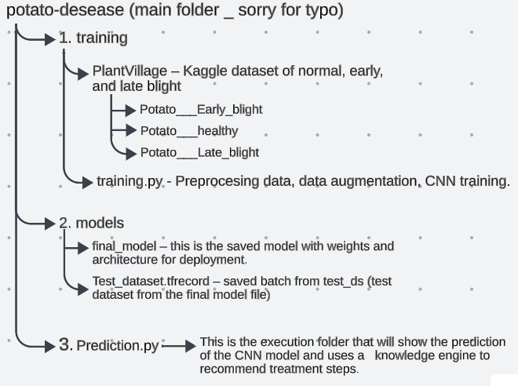Directory: